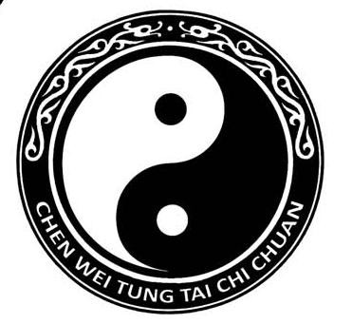
Master Tung Chen-wei’s
New Hampshire Seminar

Spring 2018

Location: Ashland Gymnasium
27 Highland St. Ashland, NH

Dates: Friday 4/27 6:00 p.m.
*Saturday 4/28 10:00 a.m.
5:00 p.m.
Sunday 4/29 10:00 a.m.- 1:00 p.m. (two classes)
* Saturday morning class is open to new students who know (or can follow) slow set
$50 cash fee payable at the door

Cost: $325
$300 if pre-register by April 12th

Accommodations:
Fairfield Inn, Plymouth 603-536-0100
Comfort Inn, Ashland 603-968-7668
Cold Springs Condos, Ashland 603-536-4600

Complete and return form below with full payment to:
Darcy Cushing
45 Merrill St
Plymouth, N.H. 03264
For further information: (603)536-2068
---------------------------------------------------------------------------------------------------------------------------------
MASTER TUNG’S
NEW HAMPSHIRE SEMINAR
SPRING 2018
Name: ______________________________________________________
TOTAL $___________ E-MAIL:________________________________________________________

